**Que 1 - Create a policy to access all objects in a specific bucket.**

Create User >> then enter in that user >> click on Add Permission >> create inline policy

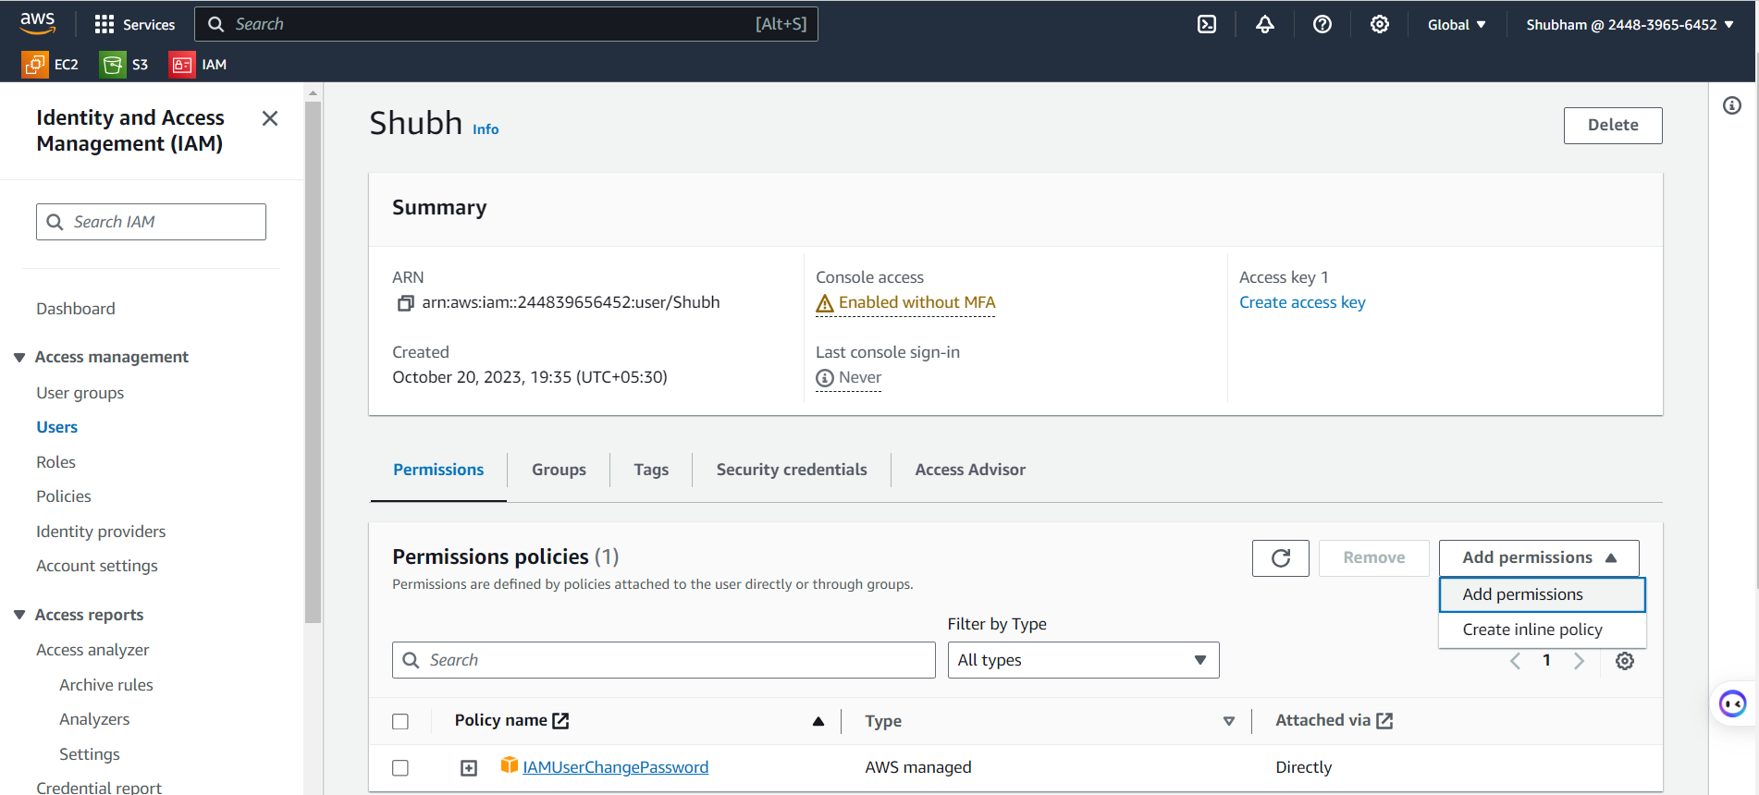

Select service >> Give the permissions what you need >> scroll down

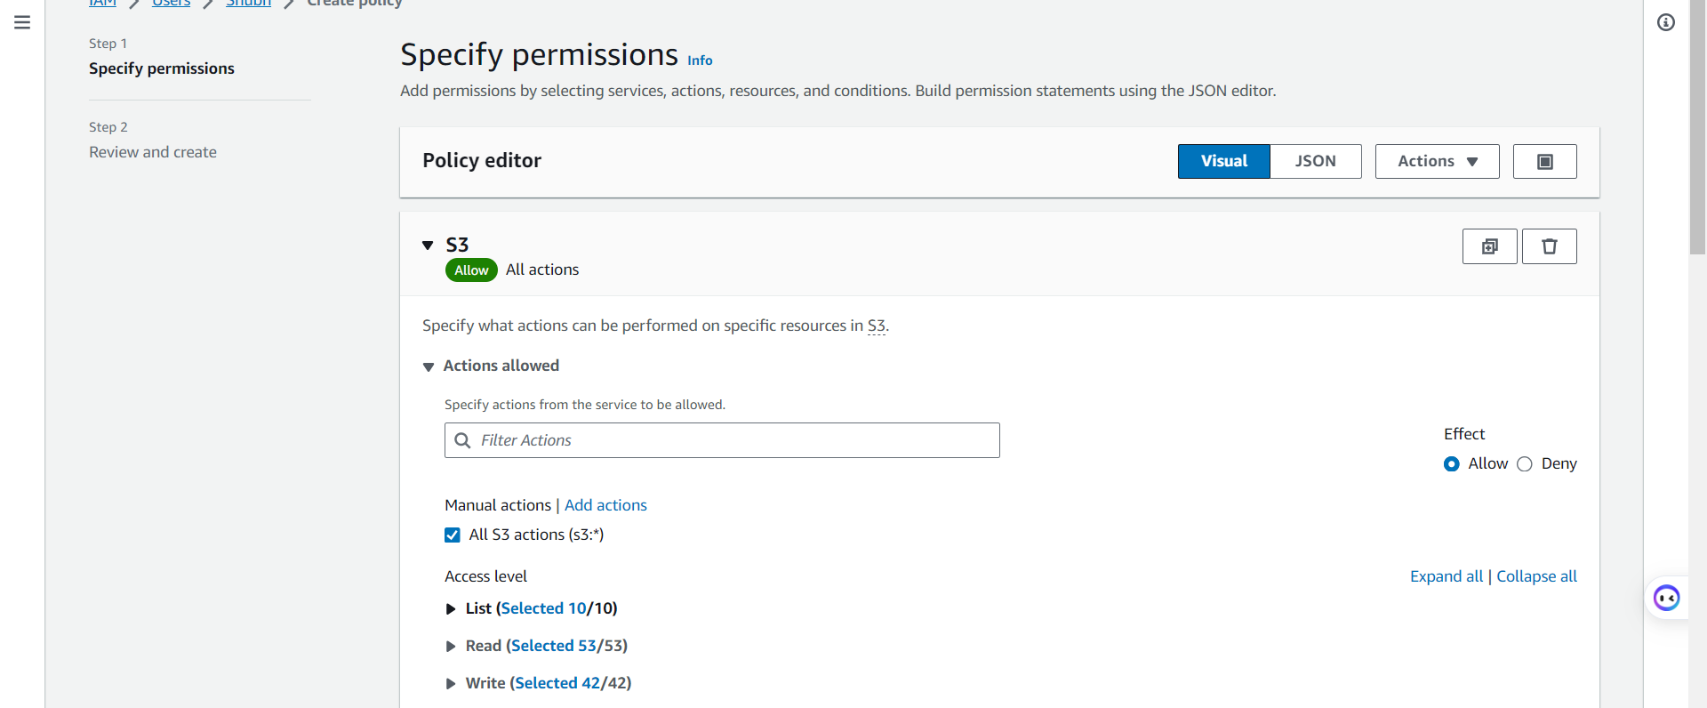

Bucket >> Add ARN >> select bucket >> click on Add ARNs

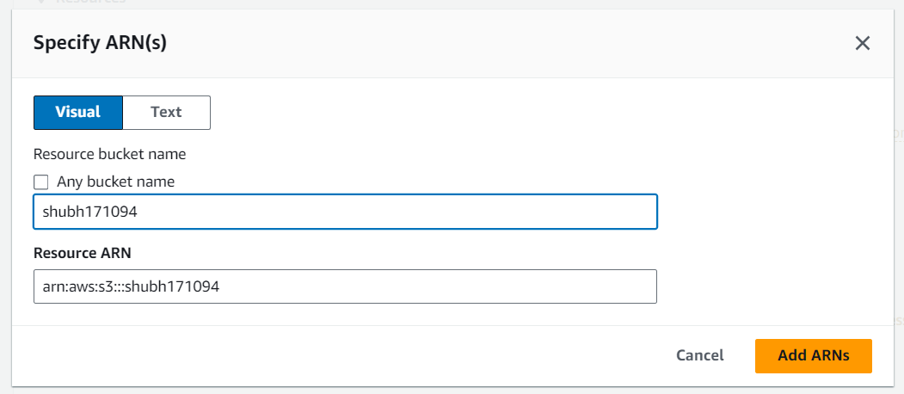

Give the Policy Name >> create policy

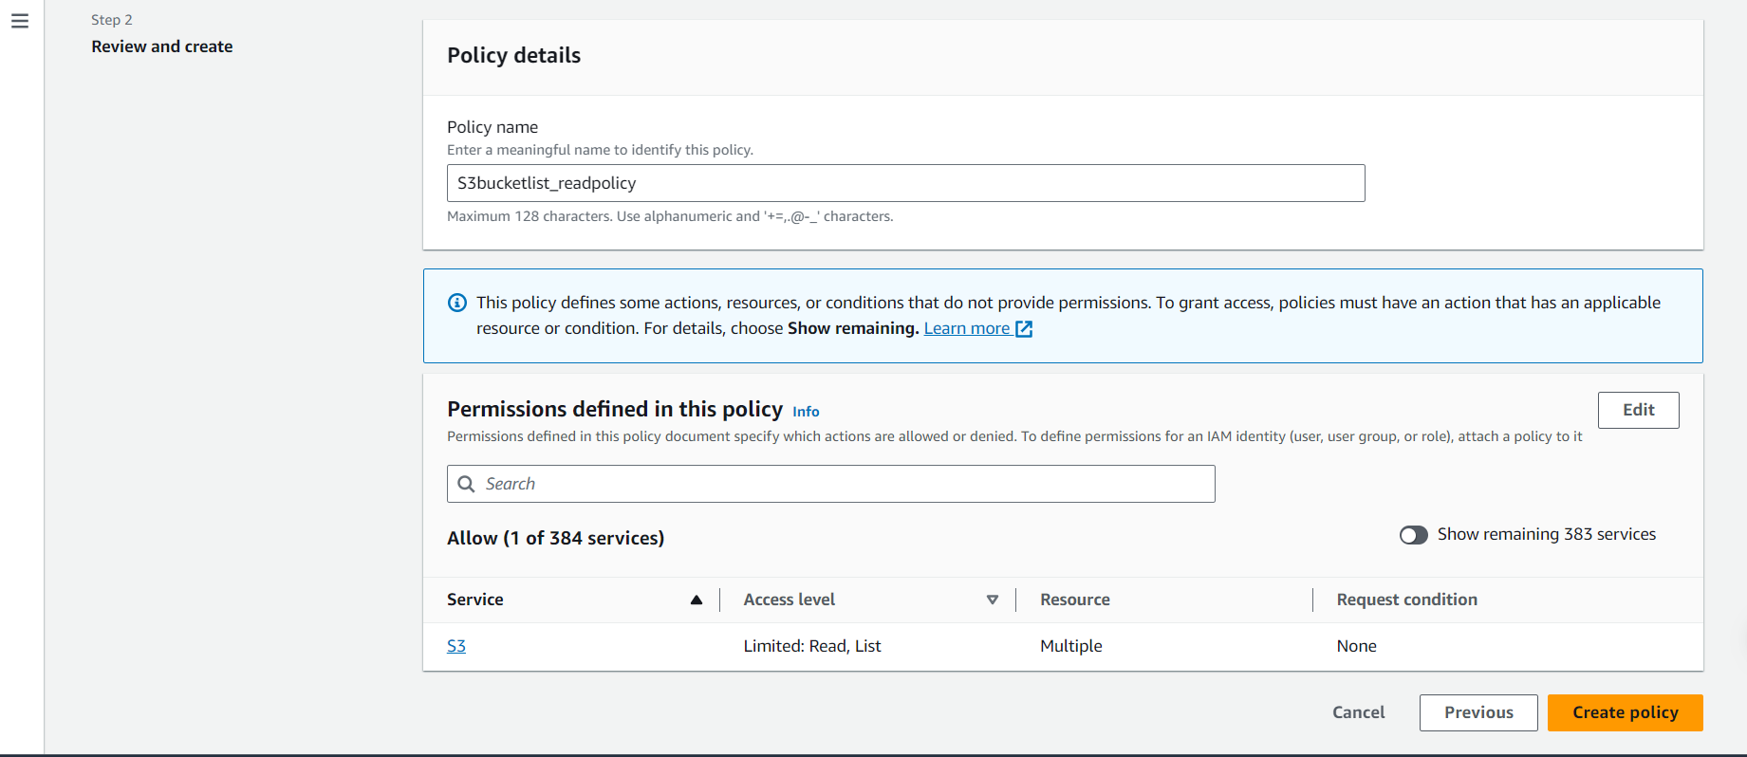

Login into that specific user >> access S3 bucket >> check the all operations which is given to that Specific user.

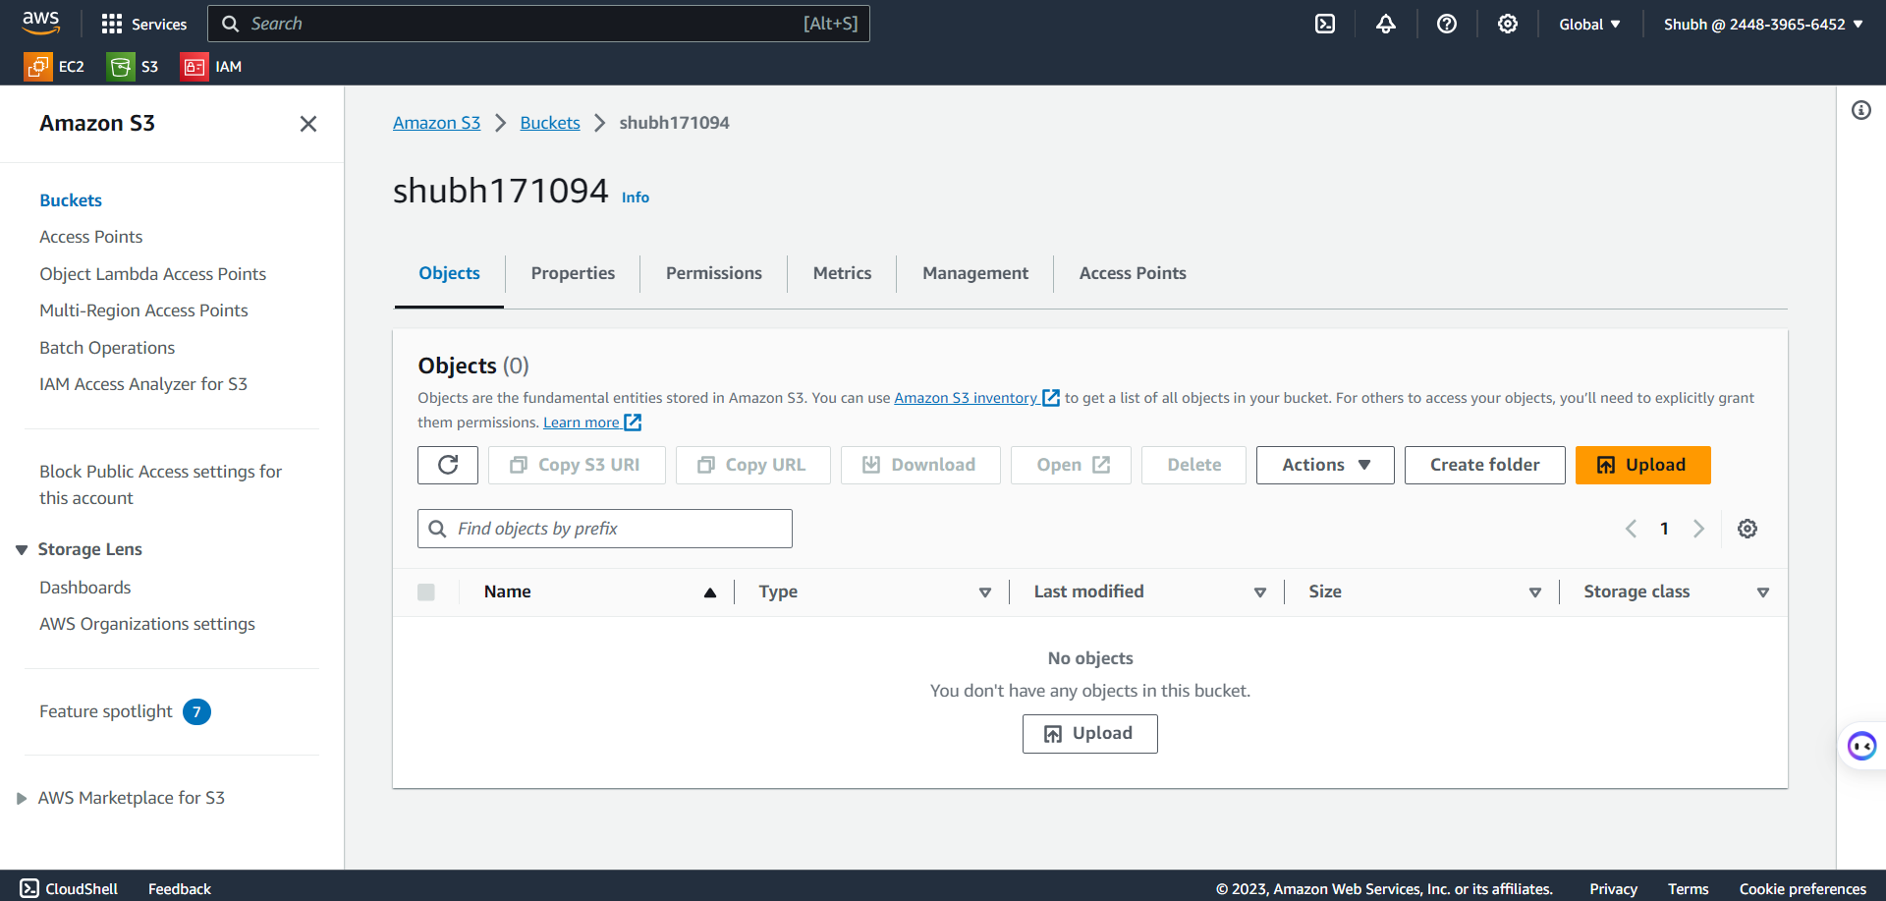

**Que 2 - Create a policy to access only 2 objects in a specific bucket.**

Create User >> then enter in that user >> click on Add Permission >> create inline policy



Select service >> Give the permissions what you need >> scroll down



Click on specific >> provide the bucket ARN

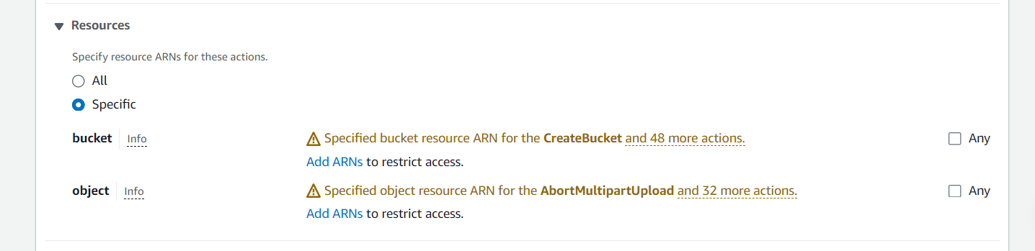

Bucket >> Add ARN >> select bucket >> click on Add ARNs



Object >> Add ARN of that particular object >> click on Add ARN [if you wants to give another object access the do the same procedure]

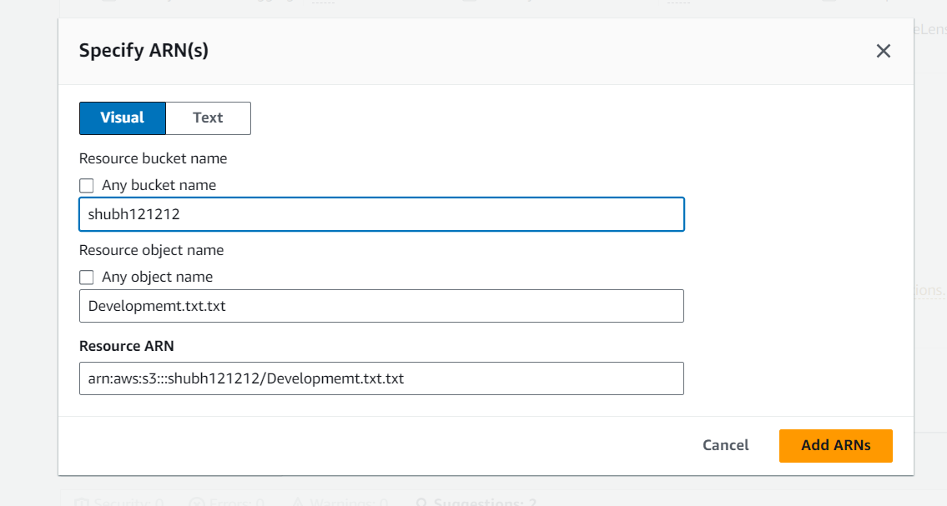

>> Give name for that policy >> create policy >> Login into that user & list the bucket & Access the objests

**Q.3 Create a policy to deny the access of Specific bucket.**

Step 1 :- Create User >> then enter in that user >> click on Add Permission >> create inline policy

Step 2 :- Select service >> Give the permissions what you need >> scroll down

Step 3 :- Specify the Bucket ARN >>

